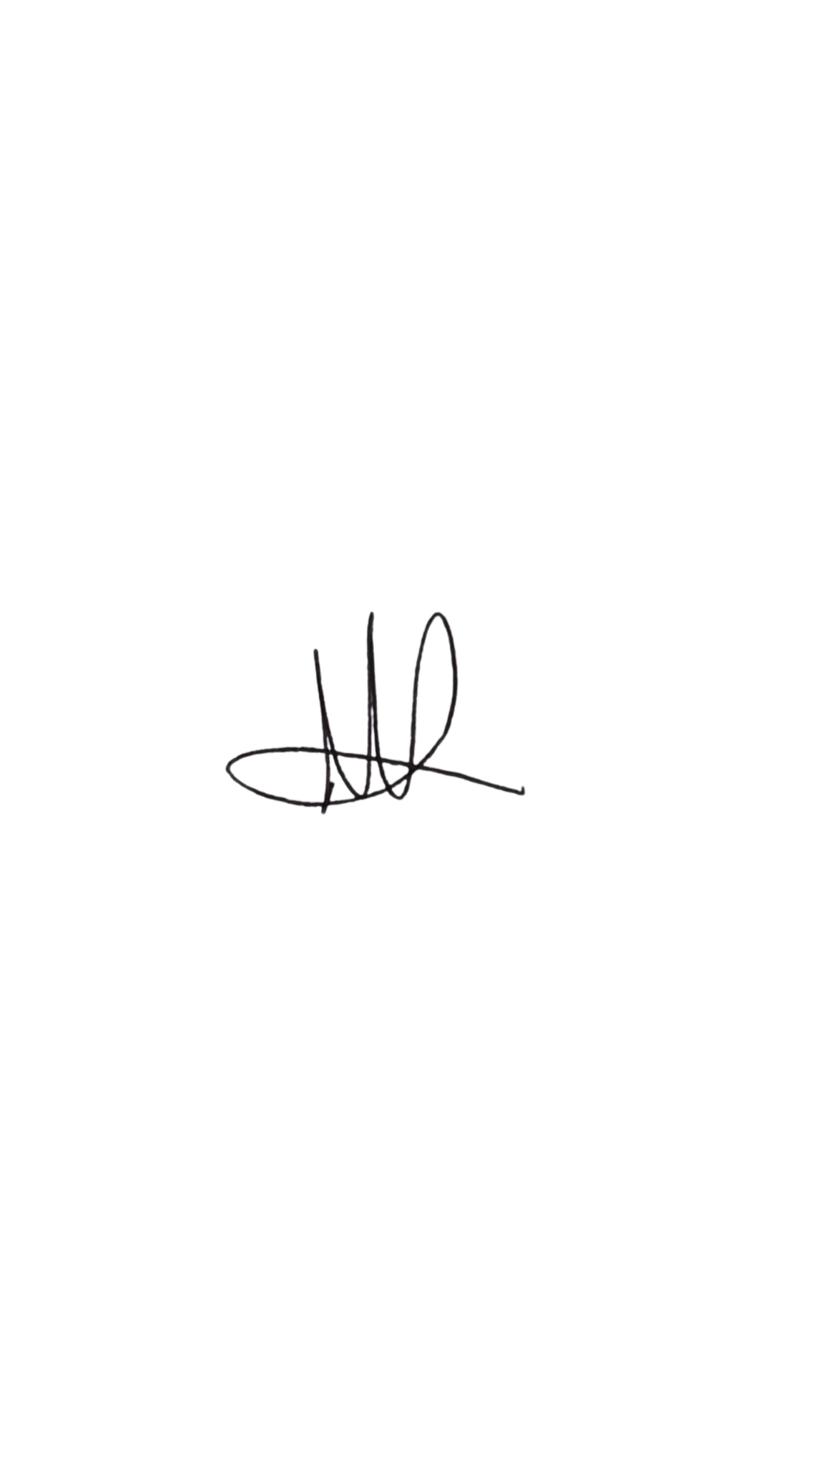

Policy Details
Date written: January 2026
Date approved by board: 02.02.26

Zwsw
s

Mark Mann (Chairman)

Next review: January 2027
Policy Owner: Stride UK Foundation Limited

Health & Safety
Policy
Statement of Intent

Stride UK Foundation recognises that effective health and safety management is fundamental to safeguarding children and young people, protecting employees and volunteers and ensuring safe service delivery across all settings.

We operate across a range of environments including:
- Sports halls and leisure centres
- Classrooms and school premises
- Community and public spaces
- 1:1 mentoring settings
- Small group work venues
- An alternative provision site including kitchen facilities

We are committed to:
- Complying with all relevant UK health and safety legislation, including:
  - Health and Safety at Work etc Act 1974
  - Management of Health and Safety at Work Regulations 1999
  - Reporting of Injuries, Diseases and Dangerous Occurrences Regulations 2013
  - Control of Substances Hazardous to Health Regulations 2002
  - Food Safety act 1990
  - Regulatory Reform (Fire Safety) Order 2005
- Implementing systems to eliminate or reduce risks so far as is reasonably practicable.
- Completing suitable and sufficient risk assessment for all activities and locations.
- Providing safe environments for children, young people, staff, volunteers and visitors.
- Ensuring appropriate safeguarding and supervision arrangements.
- Providing suitable training, instruction and supervision.
- Reporting and investigating adverse events.
- Promoting positive mental health and wellbeing.
- Continually reviewing and improving our health and safety systems.

Health and safety governance applies equally across all Stride delivery strands and external venues used.

Responsibilities for Health & Safety

Trustees / Board
- Ensure legal compliance
- Provide oversight of health and safety performance
- Review serious incidents and trends
- Ensure adequate resources are available
Senior Leadership Team (SLT)
- Ensuring suitable and sufficient risk assessments are in place.
- Embedding health and safety in all programme decisions.
- Ensuring safe systems of work across all sites.
- Ensuring incident reporting and escalation processes are robust.
- Reviewing trends and implementing corrective action.
- Ensuring safeguarding and health & safety are integrated.

Line Managers
- Health and safety within their teams and delivery locations.
- Ensuring activity, site and dynamic risk assessments are completed.
- Ensuring staff are appropriately trained (first aid, food hygiene, manual handling, safeguarding).
- Acting on hazards, near misses and concerns promptly.
- Ensuring supervision ratios are appropriate.
- Escalating serious incidents immediately.

Health & Safety Manager (with HR)
- Providing competent advice on legal compliance.
- Monitoring KPIs and trends.
- Ensuring RIDDOR reporting where required.
- Investigating incidents proportionately.
- Supporting risk assessment processes.
- Reviewing policies annually.
- Supporting mental health and wellbeing initiatives.

Employees and Volunteers
- Take reasonable care of their own and others’ safety.
- Follow risk assessments and safe systems of work.
- Report hazards, injuries and near misses immediately.
- Not misuse safety equipment.
- Cooperate with management.

Employees may refuse to work where there is serious and imminent danger and mis report concerns immediately.

Arrangements for Health & Safety

- Risk Assessments
Risk assessments will be completed for:
- Sports delivery (including equipment use, contact sport, venue hazards)
- Classroom and mentoring activities
- Public space delivery
- Off-site trips and visits
- Lone working and 1:1 mentoring
- Alternative provision site (including kitchen use)
- Young workers or work experience placements
- Fire safety
- Stress and mental health
- New and expectant mothers

Dynamic risk assessments must be conducted during activities where circumstances change.

For higher-risk activities, written method statements / safe systems of work will be produced.

- Site-Specific Arrangements

Sports Halls & Physical Activity
- Equipment must be checked before use.
- Safe storge procedures in place.
- Adequate supervision rations maintained.
- Clear emergency access roues maintained.

Classrooms & Small Group Spaces
- Furniture positioned safely.
- Behaviour management procedures in place.
- Clear evacuation procedures displayed.

Public Spaces
- Location-specific risk assessment completed.
- Clear meeting points agreed.
- Staff positioned to maintain visibility and supervision.

Alternative Provision Site (Including Kitchen)
- Food hygiene training (minimum Level 2) for relevant staff.
- Compliance with food safety legislation.
- Allergen management procedures.
- Safe storage of knives and sharp implements.
- Supervised use of cooking equipment.
- COSHH assessments for cleaning chemicals.
- Fire blanket and extinguishers in kitchen area.
- Temperature monitoring for fridges/freezers.
- Clear supervision arrangements during practical cooking sessions.

Young people must never be left unsupervised in kitchen areas.

- Adverse Events & Incident Reporting
All injuries, near misses, violent incidents and safeguarding-related health concerns must be reported.
- Serious incidents escalated immediately to SLT.
- Investigations proportionate to severity and risk.
- RIDDOR reports submitted where legally required.
- Incident trends reviewed annually by the Board.

- Emergency Arrangements
Each delivery site must have:
- A site-specific emergency plan
- Fire evacuation procedures
- Named fire marshals (where required)
- First aid provision
- Clear emergency contact details
- Annual fire drill testing (where applicable)

Staff must be inducted into site procedures before delivering work.

- First Aid
- At least one qualified First Aider must be present at each session.
- First aid kits available and checked regularly.
- Accident records completed for all injuries.
- Parents/carers informed where appropriate.

For higher-risk activities or trips, enhanced first aid provision will be considered.

- Lone Working
Where lone working cannot be avoided:
- Activity must be assessed as low risk.
- Staff must follow check-in procedures.
- Emergency contacts accessible.
- Home visits follow safeguarding protocols.

- Manual Handling
Manual handling risks (e.g. sports equipment, tables, food deliveries) will be reduced by:
- Avoiding unnecessary lifting.
- Providing manual handling training.

- Violence and Aggression
Given the nature of mentoring and alternative provision:
- Behaviour support plans must be in place where necessary.
- Staff trained in de-escalation.
- Physical intervention used only as last resort and recorded.
- Risk assessment updated following incidents.

- Work Equipment
- Equipment inspected regularly.
- Defective items removed from use immediately.
- PAT testing completed where required.
- Safe storage systems implemented.

- Substance Misuse (Drugs & Alcohol)
Employees must not:
- Work under the influence.
- Consume alcohol during working hours (unless sanctioned event).
- Permit others to work under influence.

Support will be offered where appropriate.
- Mental Health & Wellbeing
Stride UK recognises mental health as a health and safety issue.

We will:
- Complete work-related stress risk assessments.
- Encourage open conversations.
- Provide supervision and pastoral support.
- Monitor workload and role clarity.

- Young People and Young Workers
Where young people are employed, volunteering or on placement:
- A specific young person risk assessment will be completed.
- Consideration given to maturity, experience and supervision.
- Additional safeguards implemented where required.

- Safeguarding & Health & Safety Integration
Health and safety and safeguarding are interconnected. Risk assessments must consider:
- Supervision ratios
- Visibility and safe spaces
- Online safety
- Off-site and transport arrangements
- Medical needs and allergies
- Behaviour and emotional regulation risks

Monitoring and Review
Health and safety performance will be monitored through:
- Monthly KPIs to SLT
- Annual board oversight
- Incident trend analysis
- Regular workplace inspections
- External audits (where commissioned)
- Annual policy review

This policy will be reviewed annually or following significant legislative change or serious incident.

